**Day 1 18.12.2023**

**Introduction**

Completed100 XP

* 6 minutes

**Microsoft Power BI** is a collection of software services, apps, and connectors that work together to turn your unrelated sources of data into coherent, visually immersive, and interactive insights. Whether your data is a simple Microsoft Excel workbook, or a collection of cloud-based and on-premises hybrid data warehouses, **Power BI** lets you easily connect to your data sources, visualize (or discover) what's important, and share that with anyone or everyone you want.

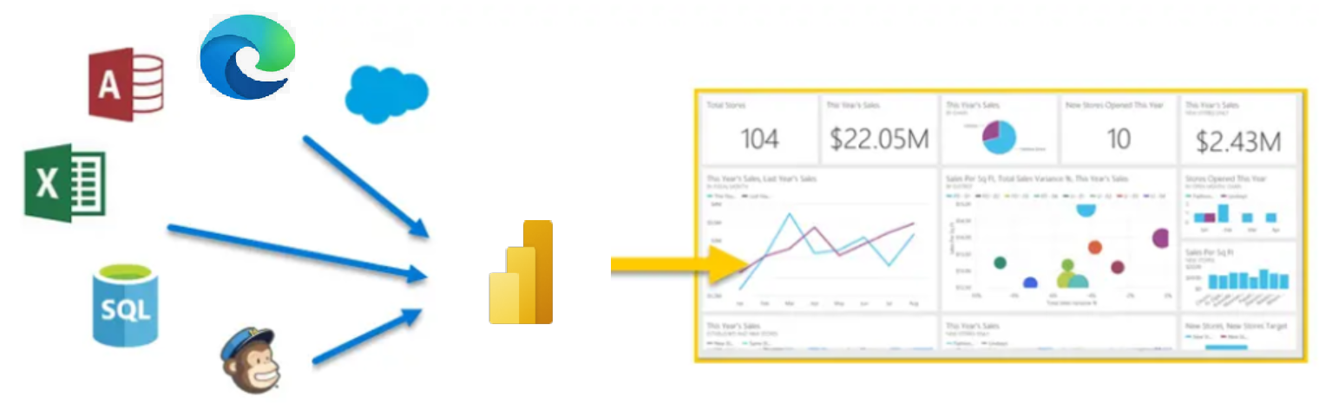

**Power BI** can be simple and fast, capable of creating quick insights from an Excel workbook or a local database. But **Power BI** is also robust and enterprise-grade, ready not only for extensive modeling and real-time analytics, but also for custom development. Therefore, it can be your personal report and visualization tool, but can also serve as the analytics and decision engine behind group projects, divisions, or entire corporations.

If you're a **beginner** with Power BI, this module will get you going. If you're a Power BI **veteran**, this module will tie concepts together and fill in the gaps.

**The parts of Power BI**

Power BI consists of a Microsoft Windows desktop application called **Power BI Desktop**, an online SaaS (*Software as a Service*) service called the **Power BI service**, and mobile Power BI **apps** that are available on any device, with native mobile BI apps for Windows, iOS, and Android.

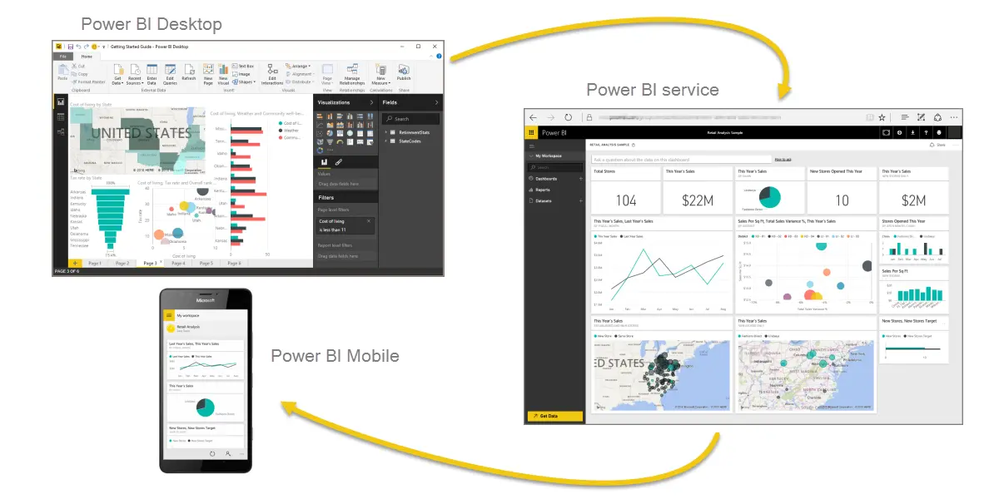

These three elements—**Desktop**, the **service**, and **Mobile** apps—are designed to let people create, share, and consume business insights in the way that serves them, or their role, most effectively.

**How Power BI matches your role**

How you use Power BI might depend on your role on a project or a team. And other people, in other roles, might use Power BI differently, which is just fine.

For example, you might view reports and dashboards in the **Power BI service**, and that might be all you do with Power BI. But your number-crunching, business-report-creating coworker might make extensive use of **Power BI Desktop** (and publish Power BI Desktop reports to the Power BI service, which you then use to view them). And another coworker, in sales, might mainly use her Power BI phone app to monitor progress on her sales quotas and drill into new sales lead details.

You also might use each element of **Power BI** at different times, depending on what you're trying to achieve, or what your role is for a given project or effort.

Perhaps you view inventory and manufacturing progress in a real-time dashboard in the service, and also use **Power BI Desktop** to create reports for your own team about customer engagement statistics. How you use Power BI can depend on which feature or service of Power BI is the best tool for your situation. But each part of Power BI is available to you, which is why it's so flexible and compelling.

We discuss these three elements—**Desktop**, the **service**, and **Mobile** apps—in more detail later. In upcoming units and modules, we'll also create reports in Power BI Desktop, share them in the service, and eventually drill into them on our mobile device.

**Download Power BI Desktop**

You can download Power BI Desktop from the web or as an app from the Microsoft Store on the Windows tab.

Expand table

| **Download Strategy** | **Link** | **Notes** |
| --- | --- | --- |
| Windows Store App | [Windows Store](https://aka.ms/pbidesktopstore) | Will automatically stay updated |
| Download from web | [Download .msi](https://go.microsoft.com/fwlink/?LinkID=521662) | Must manually update periodically |

**Sign in to Power BI service**

Before you can sign in to Power BI, you'll need an account. To get a free trial, go to [app.powerbi.com](https://go.microsoft.com/fwlink/?linkid=2101313) and sign up with your email address.

For detailed steps on setting up an account, see [Sign in to Power BI service](https://learn.microsoft.com/en-us/power-bi/consumer/end-user-sign-in)

**The flow of work in Power BI**

A common flow of work in Power BI begins in **Power BI Desktop**, where a report is created. That report is then published to the **Power BI service** and finally shared, so that users of **Power BI Mobile** apps can consume the information.

It doesn't always happen that way, and that's okay. But we'll use that flow to help you learn the different parts of Power BI and how they complement each other.

Okay, now that we have an overview of this module, what Power BI is, and its three main elements, let's take a look at what it's like to use **Power BI**.

**Use Power BI**

Completed100 XP

* 2 minutes

Now that we've introduced the basics of Microsoft Power BI, let's jump into some hands-on experiences and a guided tour.

The activities and analyses that you'll learn with Power BI generally follow a common flow. The **common flow** of activity looks like this:

1. Bring data into Power BI Desktop, and create a report.
2. Publish to the Power BI service, where you can create new visualizations or build dashboards.
3. Share dashboards with others, especially people who are on the go.
4. View and interact with shared dashboards and reports in Power BI Mobile apps.

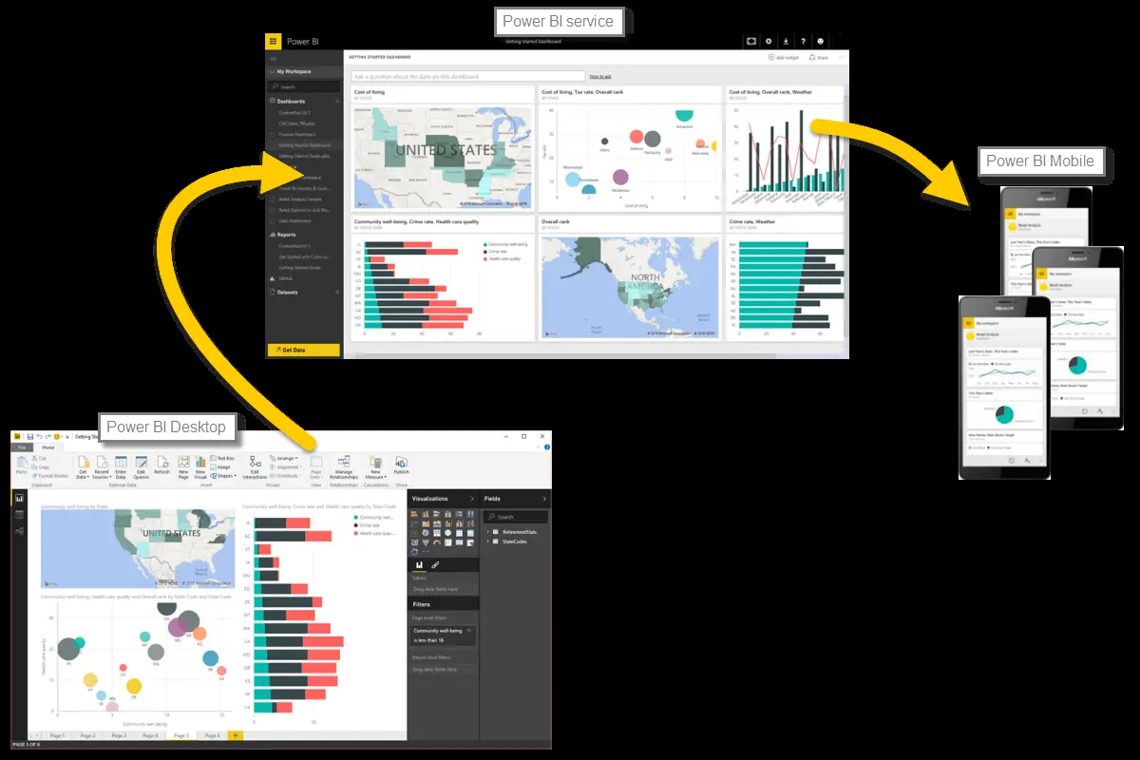

As mentioned earlier, you might spend all your time in the **Power BI service**, viewing visuals and reports that have been created by others. And that's fine. Someone else on your team might spend their time in **Power BI Desktop**, which is fine too. To help you understand the full continuum of Power BI and what it can do, we'll show you all of it. Then you can decide how to use it to your best advantage.

So, let's jump in and step through the experience. Your first order of business is to learn the basic building blocks of Power BI, which will provide a solid basis for turning data into cool reports and visuals.

**Building blocks of Power BI**

Completed100 XP

* 12 minutes

In Microsoft Power BI, there are basic building blocks that make up the reports and dashboards consumed by end users. Think of it similarly to the basic construction materials that can be used to build homes or other structures.

Here are the basic building blocks in Power BI:

* **Reports** consist of **visualizations** and **semantic models** created with Power BI Desktop application.
* **Dashboards** consist of **tiles** from report visualizations created in the online Power BI service.

**Visualizations**

A **visualization** (or **visual**) is a visual representation of data, like a chart, a color-coded map, or other interesting things you can create to represent your data visually. Power BI has all sorts of visualization types, and more are coming all the time. The following image shows a collection of different visualizations that were created in Power BI.

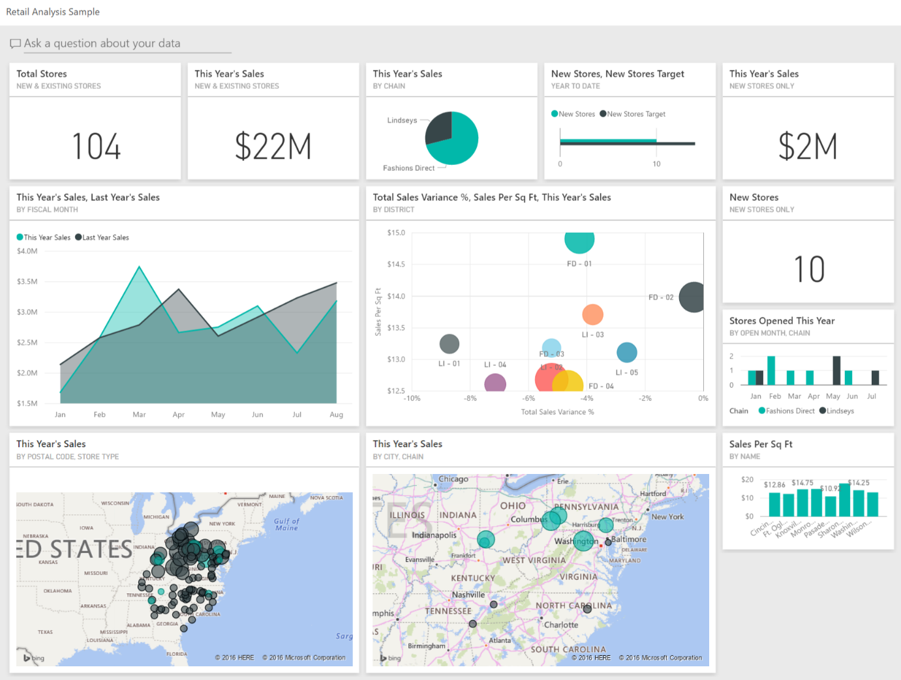

Visualizations can be simple, like a single number that represents something significant. Visuals can also be complex, like a gradient-colored map that shows voter sentiment about a certain social issue or concern. The goal of a visual is to present data in a way that provides context and insights, both of which would probably be difficult to discern from a raw table of numbers or text.

**semantic models**

A **semantic model** is a collection of data that Power BI uses to create its visualizations.

You can have a simple semantic model that's based on a single table from a Microsoft Excel workbook, similar to what's shown in the following image.

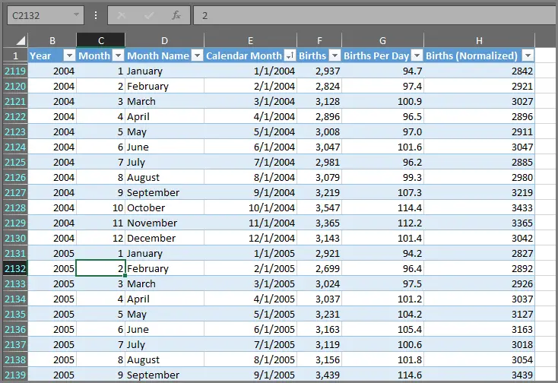

**semantic models** can also be a combination of many different sources, which you can filter and combine to provide a unique collection of data (a semantic model) for use in Power BI.

For example, you can create a semantic model from three database fields, one website table, an Excel table, and online results of an email marketing campaign. That unique combination is still considered a single **semantic model**, even though it was pulled together from many different sources.

Filtering data before bringing it into Power BI lets you focus on the data that matters to you. For example, you can filter your contact database so that only customers who received emails from the marketing campaign are included in the semantic model. You can then create visuals based on that subset (the filtered collection) of customers who were included in the campaign. Filtering helps you focus your data—and your efforts.

You can create a Power BI report from almost any data, thanks to the many available **data connectors**, such as Excel, a Microsoft SQL Server database, Azure, Oracle, Facebook, Salesforce, and MailChimp.

After you have a semantic model, you can begin creating visualizations that show different portions of it in different ways, and gain insights based on what you see. That's where reports come in.

**Reports**

In Power BI, a **report** is a collection of visualizations on one or more pages. As with other reports you've seen or created, Power BI reports combine related data. The following image shows a **report** in Power BI Desktop—in this case, it's the second page in a five-page report.

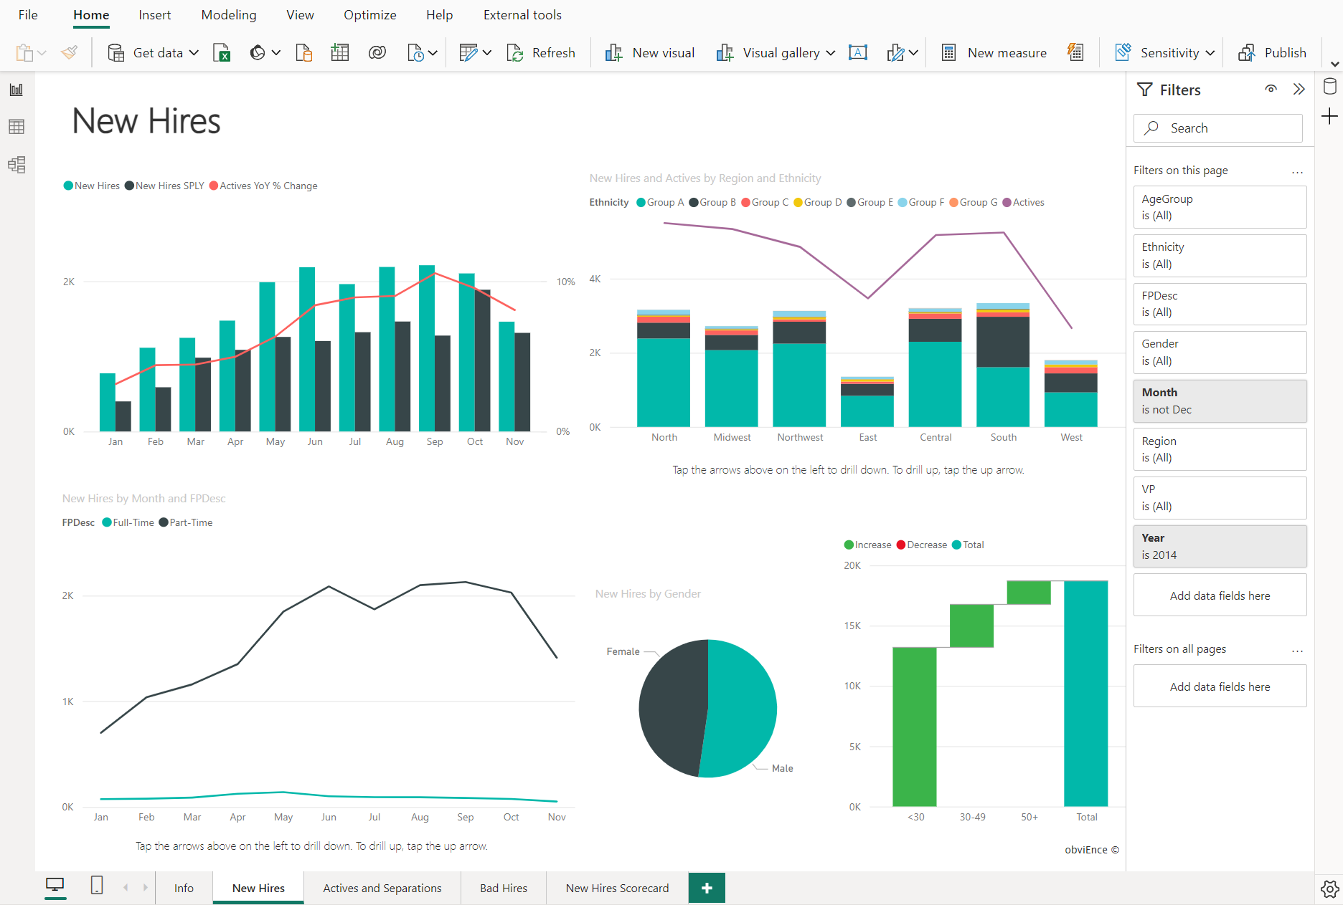

Reports let you create many visualizations, on multiple pages if necessary, and let you arrange those visualizations in whatever way best tells your story.

You might have a report about quarterly sales, product growth in a particular segment, or migration patterns of polar bears. Whatever your subject, reports let you gather and organize your visualizations onto one page (or more).

**Dashboards**

When you're ready to share a report, or a collection of visualizations, you can create a Power BI **dashboard**. Much like the dashboard in a car, a dashboard is a selected group of visuals that provide quick and important insight into the data or story you're trying to present.

Dashboards are limited to a single page, and allow users to follow a visual to the underlying report. Users interact with dashboards through the Power BI service or on a mobile device.

**Tiles**

In Power BI, a **tile** is a single visualization on a dashboard. It's the rectangular box that holds an individual visual. In the following image, you see one tile, which is also surrounded by other tiles.

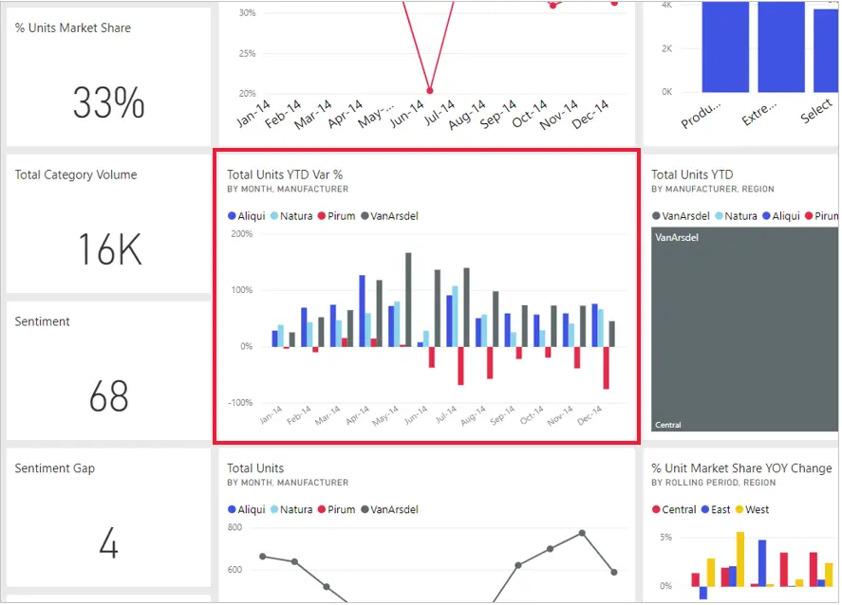

When you're *creating* a dashboard in Power BI, you can move or arrange tiles however you want. You can make them bigger, change their height or width, and snuggle them up to other tiles.

When you're *viewing*, or *consuming*, a dashboard or report—which means you're not the creator or owner, but the report or dashboard has been shared with you—you can interact with it, but you can't change the size of the tiles or their arrangement.

**All together now**

Let's review the building blocks of Power BI:

* Power BI Desktop lets you build semantic models and use visuals to make reports.
* The online Power BI service brings together reports, dashboards, and tools for easy distribution and management of your Power BI content.

Understanding the Power BI basics empowers you to create semantic models and design reports. Your reports don't have to be complex to be interesting and informative. Power BI offers easy ways to design reports from a single Excel sheet.

Power BI is also scalable, allowing you to create semantic models from various data sources, even incorporating custom code. The semantic model can then be used to design interactive reports and dashboards that emphasize crucial data for informed business decisions.

No matter how you use Power BI, it all starts with semantic models and visuals. These are the foundation for your reports that share insights and dashboards that present the most important data upfront.

**Tour and use the Power BI service**

Completed100 XP

* 12 minutes

The common flow of work in Microsoft Power BI is to create a report in Power BI Desktop, publish it to the Power BI service, and then distribute to consumers to view through the service or mobile app.

Power BI service allows you to create **apps** for easy distribution and clutter-free consumption. An **app** is a way to group related reports and dashboards and distribute to the appropriate audience(s).

We go into more detail about apps (and the service) in upcoming modules, but let's walk through the experience to understand how apps benefit your organization.

**Explore built-in sample reports**

Easily explore built-in samples to get familiar using the Power BI service. Built-in samples are each a bundle of one or more dashboards, semantic models, and reports that you can use with the Power BI service.

From the [Power BI service](https://app.powerbi.com/), open the *Learning center* from the left navigation pane. Pick one of the available built-in samples, which opens in Reading mode. Power BI then imports the sample and adds a new report and semantic model to your *My workspace*.

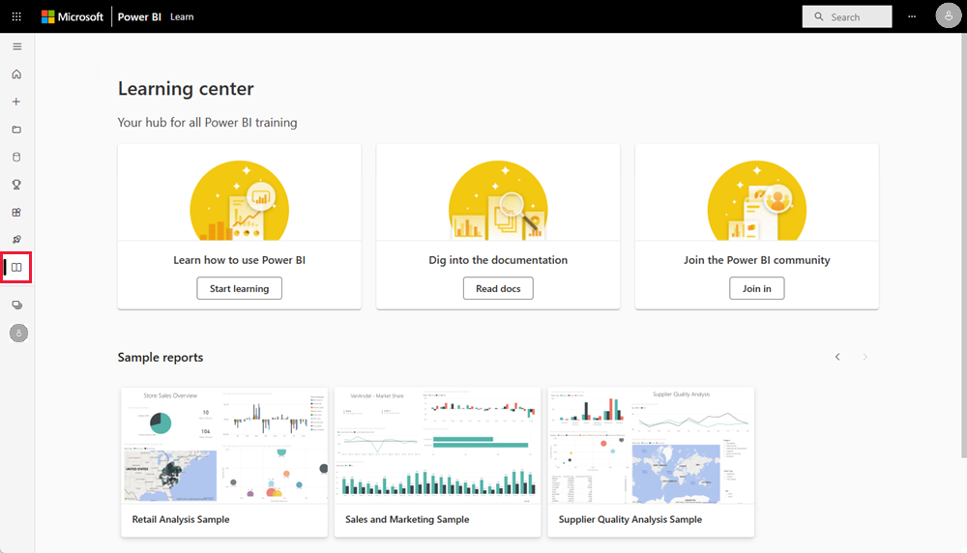

After you've chosen a sample report, you can see the direct report sharing experience for consumers. Take note of the Power BI service navigation pane and header, as shown in the following screenshot. You can see the report navigation and the filter pane, both of which are collapsible.

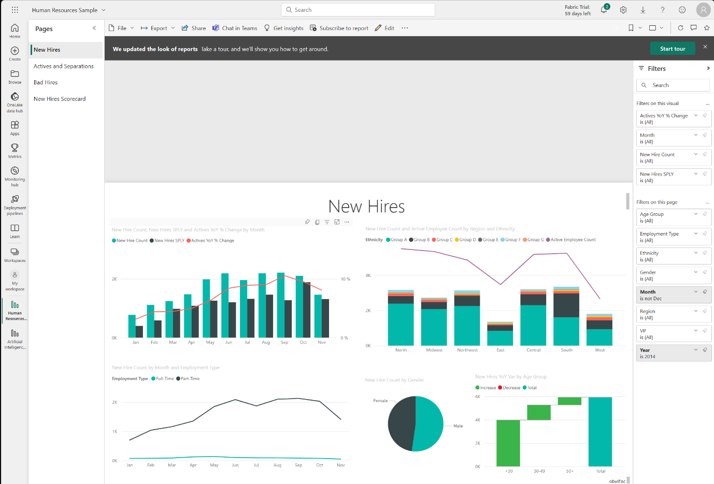

**Explore template apps**

Now that you understand how a report can be shared through Power BI service, let's look at the app experience. To replicate the experience, we're using the GitHub template app.

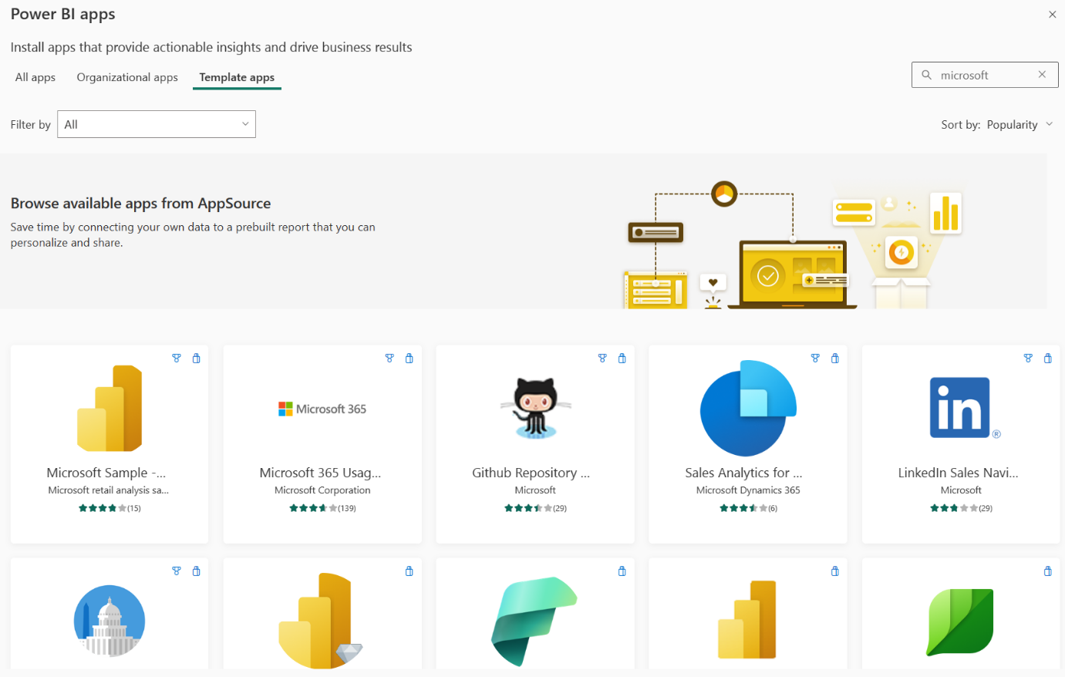

**Tip**

To access template apps, select the Apps icon from the left navigation pane > Get apps > Template apps.

In the following screenshot, you can see that the Power BI service left navigation pane and header that were visible with the direct report are gone. Also note the dashboard and a multi-page report in the app navigation pane. The app provides a cleaner look with only the relevant content. It's also customizable with app color and thumbnail. Apps also allow you to configure multiple audiences if you need to limit access to certain pages in a report, for instance.

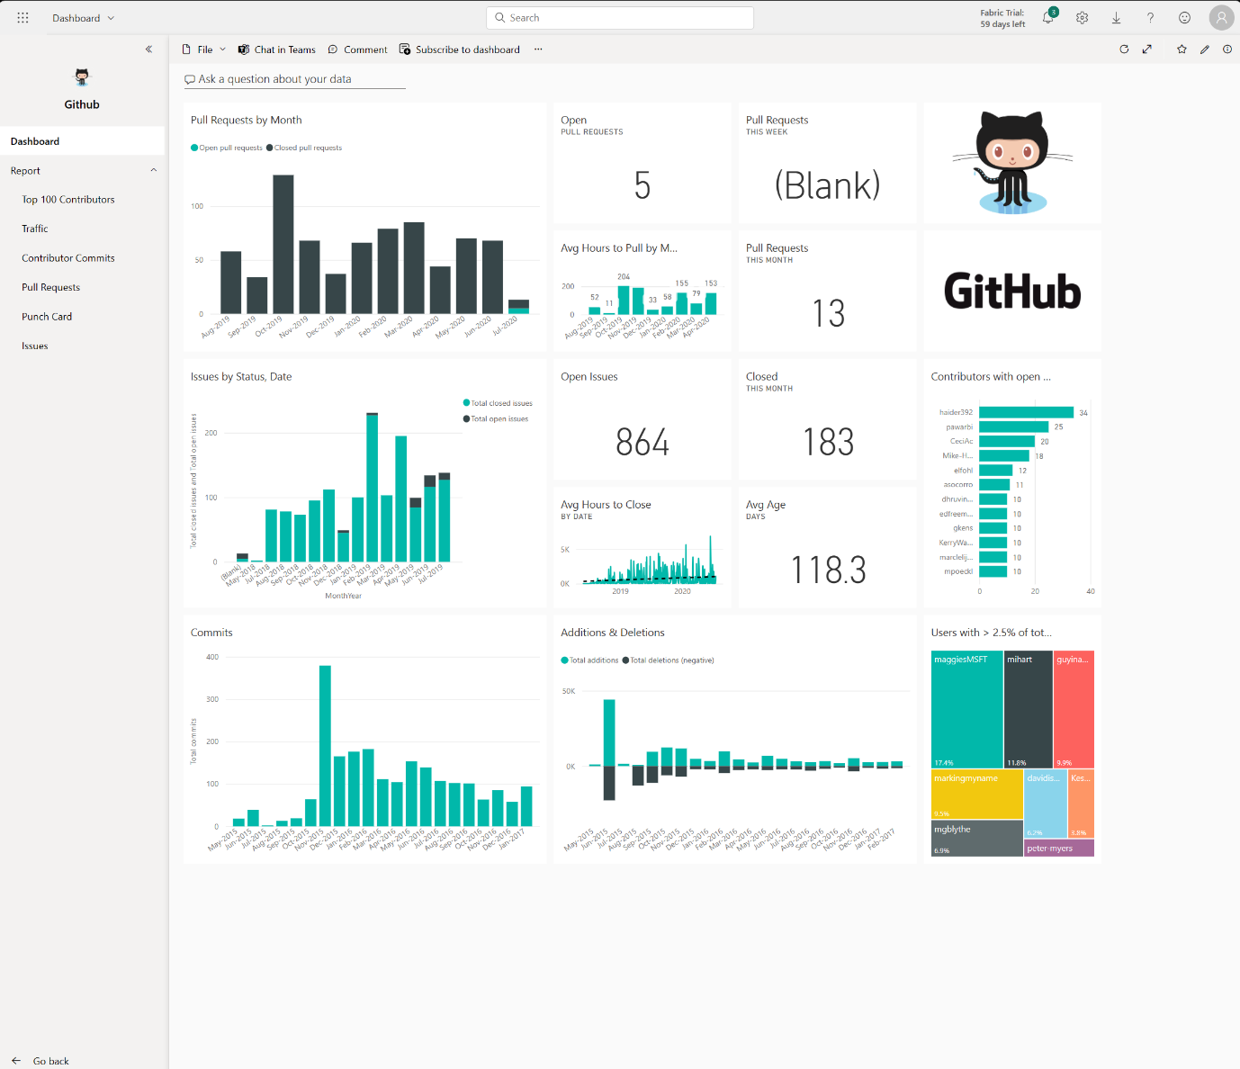

All of the visuals are interactive and interacting with one visual filters the others accordingly. For example, when you select on **mihart** in the donut chart on the **Top 100 Contributors** report, all other visuals only show related data for mihart.

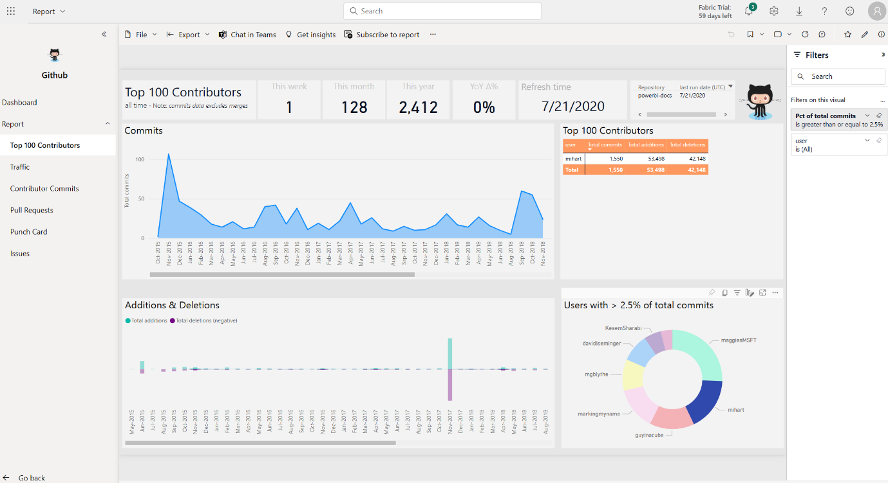

**Refresh data in the Power BI service**

Likely, your data changes regularly, so Power BI accounts allows on-demand and scheduled semantic model refreshes. From the app workspace, you manually refresh or schedule up to eight refreshes per day at minimum.

**Tip**

For more information about all refresh schedules, see the [**Refresh data documentation.**](https://learn.microsoft.com/en-us/power-bi/connect-data/refresh-data#configure-scheduled-refresh)

The **semantic models** tab is selected on the **Settings** page that appears. In the right pane, select the arrow next to **Scheduled refresh** to expand that section. The **Settings** dialog box appears on the canvas, letting you set the update settings that meet your needs.

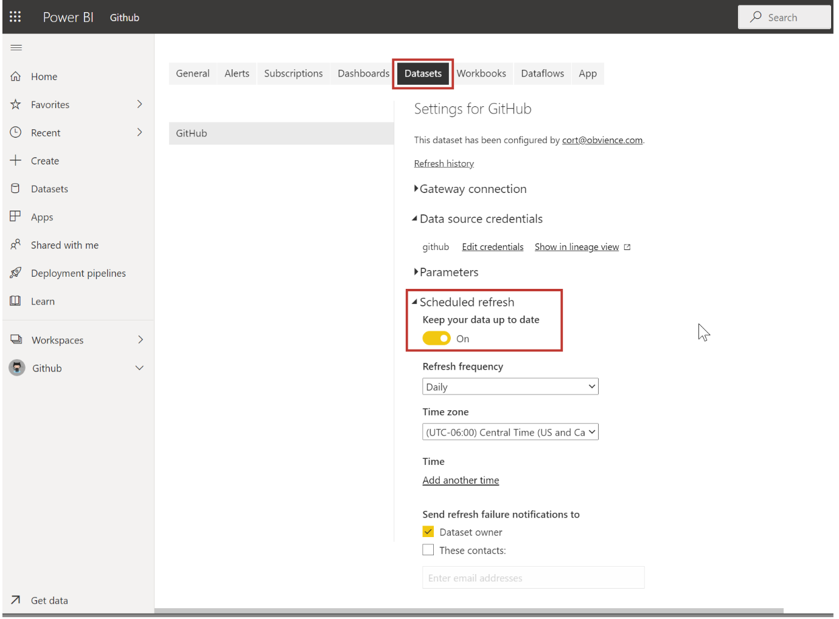

The Power BI service provides a simple and interactive user experience to take your data analytics to the next level.

**Knowledge check**

200 XP

* 3 minutes

Top of Form

**1.**

**What is the common flow of activity in Power BI?**

Create a report in the Power BI service, share it to Power BI mobile, interact with it in Power BI Desktop.

Bring data into Power BI Desktop and create a report, share it to the Power BI service, view and interact with reports and dashboards in the service and Power BI mobile.

Bring data into Power BI mobile, create a report, then share it to Power BI Desktop.

**2.**

**Which of the following are building blocks of Power BI?**

Tiles, dashboards, databases, mobile devices.

Visualizations, semantic models, reports, dashboards, tiles.

Visual Studio, C#, and JSON files.

**3.**

**What is a collection of reports and dashboards called in Power BI?**

The canvas.

Scheduled refresh.

An app.

Bottom of Form

**Summary**

Completed100 XP

* 5 minutes

**Microsoft Power BI** is a comprehensive set of software tools, apps, and connectors that transform data into interactive insights. It accommodates various data sources and can be tailored to match your organization's complexity.

The core components and building blocks of Power BI are:

* **Power BI Desktop** for authoring reports made up of semantic models and visualizations.
* **Power BI service** for creating dashboards from published reports and distributing content with apps.
* **Power BI Mobile** for on-the-go access to the Power BI service content, designed for mobile.

# ****Lab instructions****

# Get Data in Power BI Desktop

## ****Lab story****

This lab is designed to introduce you to Power BI Desktop application and how to connect to data and how to use data preview techniques to understand the characteristics and quality of the source data. The learning objectives are:

* Open Power BI Desktop
* Connect to different data sources
* Preview source data with Power Query
* Use data profiling features in Power Query

**This lab should take approximately 30 minutes.**

## ****Get started with Power BI Desktop****

In this task, you start by opening a starter Power BI (.pbix) file. The starter file doesn't contain any data, but has been specially configured to help you complete the lab. The following report-level settings have been disabled in the starter file:

* Data Load > Import relationships from data sources on first load
* Data Load > Autodetect new relationships after data is loaded

Note: While having these two options enabled can be helpful when developing a data model, you disabled them earlier to support the lab experience. When you create relationships in the ***Load Transformed Data in Power BI Desktop*** lab, you’ll learn why you're adding each one.

1. Open Power BI Desktop.

Tip: By default, the Getting Started dialog box opens in front of Power BI Desktop. You can choose to sign-in, and then close the pop-up.

1. To open the starter Power BI Desktop file, select the **File > Open Report > Browse Reports**.
2. In the **Open** window, navigate to the **D:\PL300\Labs\01-prepare-data-with-power-query-in-power-bi-desktop\Starter** folder.
3. Select the **Sales Analysis** file.
4. Save a copy of the file with **Save As** in to the **D:\PL300\MySolution** folder.

## ****Get data from SQL Server****

This task teaches you how to connect to a SQL Server database and import tables, which create queries in Power Query.

1. On the **Home** ribbon tab, from inside the **Data** group, select **SQL Server**.
2. In the **SQL Server Database** window, in the **Server** box, enter **localhost**, then select **OK**.

Note: In this lab, you’ll connect to the SQL Server database by using ***localhost*** because gateway data sources can't resolve ***localhost***. This isn’t a recommended practice when creating your own solutions.

1. If prompted for credentials, in the **SQL Server Database** window, select **Use my current credentials**, and then **Connect**.
2. In the **Navigator** window, at the left, expand the **AdventureWorksDW2020** database.

Note: The ***AdventureWorksDW2020*** database is based on the ***AdventureWorksDW2017*** sample database. It has been modified to support the learning objectives of the course labs.

1. Select—but don’t check—the **DimEmployee** table.
2. In the right pane, notice a preview of the table data. The preview data allows you to see the columns and a sample of rows.
3. To create queries, select the checkbox next to the following six tables:
   * DimEmployee
   * DimEmployeeSalesTerritory
   * DimProduct
   * DimReseller
   * DimSalesTerritory
   * FactResellerSales
4. Complete this task by selecting **Transform Data**, which will open Power Query Editor.
   * This lab is only intended to connect to and profile the data, but not ***transform data***.

## ****Preview Data in Power Query Editor****

This task introduces the Power Query Editor and allows you to review and profile the data. This helps you determine how to clean and transform the data later.

1. In the **Power Query Editor** window, at the left, notice the **Queries** pane. The **Queries** pane contains one query for each table you checked.
2. Select the first query—**DimEmployee**.

The ***DimEmployee*** table in the SQL Server database stores one row for each employee. A subset of the rows from this table represents the salespeople, which will be relevant to the model you’ll develop.

1. At the bottom left corner of the status bar, some table statistics are provided—the table has 33 columns, and 296 rows.
2. In the data preview pane, scroll horizontally to review all columns. Notice that the last five columns contain **Table** or **Value** links.

These five columns represent relationships to other tables in the database. They can be used to join tables together. You’ll join tables in the ***Load Transformed Data in Power BI Desktop*** lab.

1. To assess column quality, on the **View** ribbon tab, from inside the **Data Preview** group, check **Column Quality**. The column quality feature allows you to easily determine the percentage of valid, error, or empty values found in columns.
2. Notice that the **Position** column has 94% empty (null) rows.
3. To assess column distribution, on the **View** ribbon tab, from inside the **Data Preview** group, check **Column Distribution**.
4. Review the **Position** column again, and notice that there are four distinct values, and one unique value.
5. Review the column distribution for the **EmployeeKey** column—there are 296 distinct values, and 296 unique values.

When the distinct and unique counts are the same, it means the column contains unique values. When modeling, it’s important that some model tables have unique columns. These unique columns can be used to create one-to-many relationships, which you'll do in the ***Model Data in Power BI Desktop*** lab.

1. In the **Queries** pane, select the **DimEmployeeSalesTerritory** query.

The ***DimEmployeeSalesTerritory*** table stores one row for each employee and the sales territory regions they manage. The table supports relating many regions to a single employee. Some employees manage one, two, or possibly more regions. When you model this data, you’ll need to define a many-to-many relationship.

1. In the **Queries** pane, select the **DimProduct** query. The **DimProduct** table contains one row per product sold by the company.
2. Horizontally scroll to reveal the last columns. Notice the **DimProductSubcategory** column.

When you add transformations to this query in the ***Load Transformed Data in Power BI Desktop*** lab, you’ll use the ***DimProductSubcategory*** column to join tables.

1. In the **Queries** pane, select the **DimReseller** query.

The ***DimReseller*** table contains one row per reseller. Resellers sell, distribute, or value add to the Adventure Works products.

1. To view column values, on the **View** ribbon tab, from inside the **Data Preview** group, check **Column Profile**.
2. Select the **BusinessType** column header, and notice the new pane beneath the data preview pane.
3. Review the column statistics and value distribution in the data preview pane.

Notice the data quality issue: there are two labels for warehouse (***Warehouse***, and the misspelled ***Ware House***).

1. Hover the cursor over the **Ware House** bar, and notice that there are five rows with this value.

You’ll apply a transformation to relabel these five rows in the ***Load Transformed Data in Power BI Desktop*** lab.

1. In the **Queries** pane, select the **DimSalesTerritory** query.

The ***DimSalesTerritory*** table contains one row per sales region, including ***Corporate HQ*** (headquarters). Regions are assigned to a country, and countries are assigned to groups. In the ***Model Data in Power BI Desktop*** lab, you’ll create a hierarchy to support analysis at region, country, or group level.

1. In the **Queries** pane, select the **FactResellerSales** query.

The ***FactResellerSales*** table contains one row per sales order line—a sales order contains one or more line items.

1. Review the column quality for the **TotalProductCost** column, and notice that 8% of the rows are empty.

Missing ***TotalProductCost*** column values is a data quality issue. To address the issue, in the ***Load Transformed Data in Power BI Desktop*** lab, you’ll apply transformations to fill in missing values by using the product standard cost, which is stored in the related ***DimProduct*** table.

## ****Get data from a CSV file****

In this task, you'll create a new query based on CSV files.

1. To add a new query, in the **Power Query Editor** window, on the **Home** ribbon tab, from inside the **New Query** group, select the **New Source** down-arrow, and then select **Text/CSV**.
2. In the **Open** window, navigate to the **D:\PL300\Resources** folder, and select the **ResellerSalesTargets.csv** file. Select **Open**.
3. In the **ResellerSalesTargets.csv** window, review the preview data. Select **OK**.
4. In the **Queries** pane, notice the addition of the **ResellerSalesTargets** query.

The ***ResellerSalesTargets*** CSV file contains one row per salesperson, per year. Each row records 12 monthly sales targets (expressed in thousands). The business year for the Adventure Works company commences on July 1.

1. Notice that no column contains empty values. When there isn’t a monthly sales target, a hyphen character is stored instead.
2. Review the icons in each column header, to the left of the column name. The icons represent the column data type. **123** is whole number, and **ABC** is text.
3. Repeat the steps to create a query based on the **D:\PL300\Resources\ColorFormats.csv** file.

The ***ColorFormats*** CSV file contains one row per product color. Each row records the HEX codes to format background and font colors.

You should now have two new queries, ***ResellerSalesTargets*** and ***ColorFormats***.

### **Finish up**

In this task, you'll complete the lab.

1. On the **View** ribbon tab, from inside the **Data Preview** group, uncheck the three data preview options that were previously enabled in this lab:
   * Column quality
   * Column distribution
   * Column profile
2. **Save** the Power BI Desktop file. When prompted to apply the pending changes, select **Apply Later**.

Tip: Applying the queries will load their data to the data model. You’re not ready to do that, as there are many transformations that must be applied first.

# Congratulations!

You have successfully completed this Module, to mark the lab as complete click **End**.